BATTISFORD PARISH COUNCIL
Clerk: Teresa Davis 07719208444
clerk@battisfordpc.org.uk
http://www.battisfordpc.org.uk

The PRESS and PUBLIC are invited to attend, the Councillors are SUMMONED TO ATTEND THE BATTISFORD PARISH COUNCIL MEETING to be held at Battisford Village Hall on 17thMay 2022 commencing at 7.00pm
Signed: 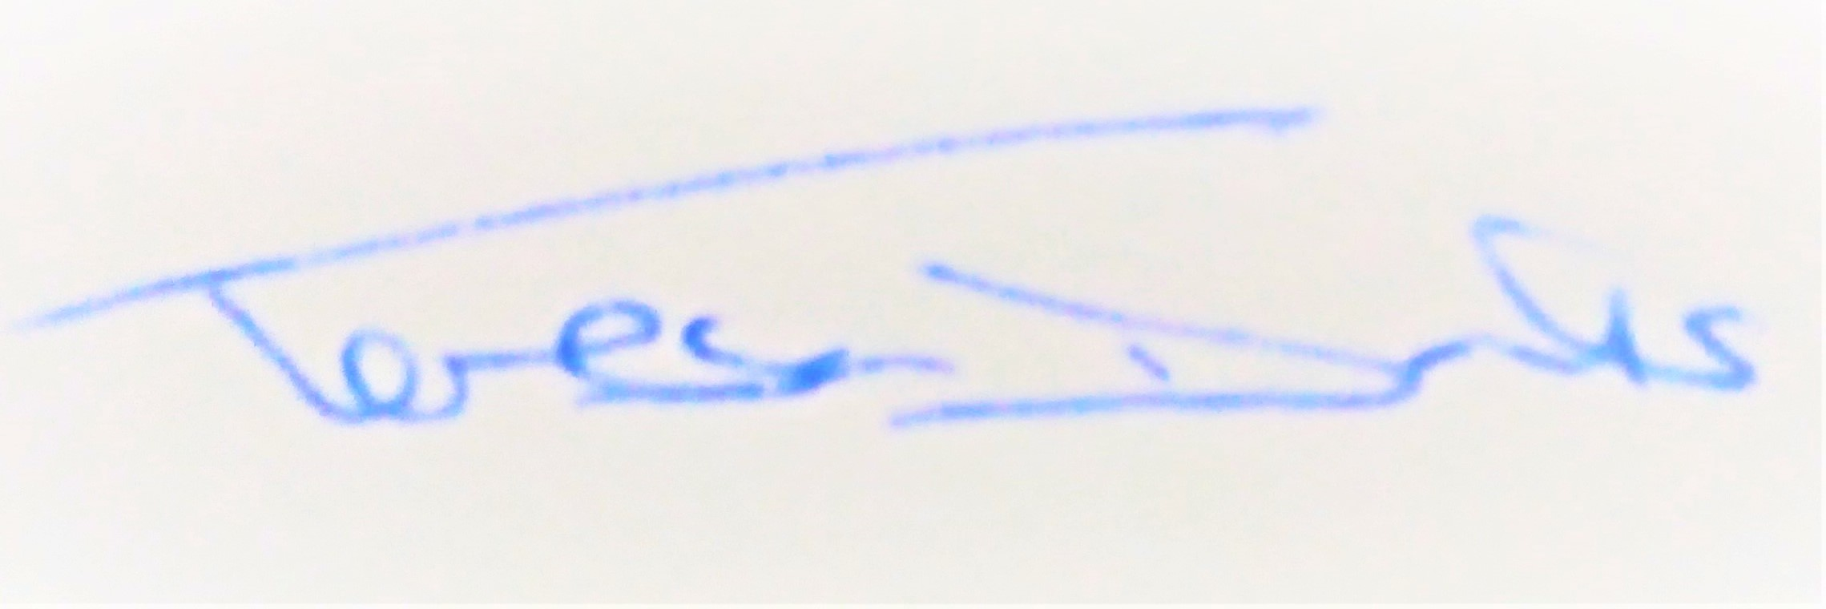
AGENDA
2022/30 | MEETING ADMINISTRATION – Previous Chair to open meeting
a.  b.  c.  d. | To Elect the Chair and Vice Chair of Battisford Parish Council  To sign Acceptance of Declaration of Office  To consider & Approve Apologies for absence  To receive Declarations of interest on agenda items
2022/31  a. | To Approve the Draft Minutes of the Parish Council Meeting of 15th March 2022 and for the Chair to sign as a true record  Matters arising from the minutes of 15th March 2022
2022/32  a.  b.  c. | PUBLIC PARTICIPATION - For members of the public, County Councillors & District Councillors to speak  Public invited to speak  To receive Suffolk County Council report from Cty Cllr K Oakes  To receive District Council report from Dst Cllr D Pratt
2022/33  a.  b.  c.  d. | Chair and Councillor Reports / Updates (on the night not requiring a decision)  Chairman report  Councillor report(s)  SID Report & ANPR update  Clerk report
2022/34 | To discuss and agree proposed dates for Parish Council meetings up to May 2023 and the APM for 2023
2022/35  a.  b.  c.  d.  e.  f.  g.  h.  i. | To discuss & adopt or readopt the following policies, forms and codes of practice:-  Transparency Code for Smaller Authorities  ICO Model Publication Scheme  Management Risk Assessment  NALC Financial Regulations  NALC Standing Orders 2020  Internal Control Statement and to appoint a non-authorised member for the internal control review for 2022-2023  LGA Model Code of Conduct 2020  Data Consent Form  Data Policies
2022/36 | To discuss forming new Committees or Working Groups for 2022-2023
2022/37 | To discuss & approve Bankers for 2022-23
2022/38 | To discuss and approve 4th Quarter (end of year Accounts)
2022/39 | To review and approve a Restatement of 2020-2021 Accounts
2022/40 | To review and approve Internal Auditor Report for 2021-2022 accounts
2022/41 | To review & approve the Annual Governance & Accountability Return Section 1 (Resolution required)
2022/42 | To review & approve the Annual Governance & Accountability Return Section 2 (Resolution required)
2022/43 | To review & approve the Certificate of Exemption
2022/44 | To discuss the Governance Review being undertaken by BMSDC (27th May)
2022/45 | To discuss the National Grid Upgrade Consultation – GREEN ( 16th June )
2022/46  a.  b.  c.  d.  e. | ENVIRONMENTAL/ FACILITY / ASSET MATTERS  To discuss Dangerous Dog Report in the Village  To discuss Festival of Suffolk Torch Rally – providing a contact in the village  To discuss the Pond on The Green  To discuss the need for using Wifi at the Village Hall  To discuss purchasing two benches for the Play Area of the Green.
2022/47  a. | Neighbourhood Plan  To review the information from the Neighbourhood plan working group and decide on the findings
2022/48  a.  b.  c.  d.  e.  f.  g.  h. | FINANCE  To advise Payments Made after meeting of 15th March 2022  - Volunteer Expense (replacement Padlock for Gate) – £17.80  - iCloud Website & Email fees - £145.00  - Clerk Wages for April - £304.98  - Clerk backdated Pay (1.75% rise) - £33.00  - Purchase of materials for Village Sign Repair - £38.85  To advise of reoccurring payments expected for 2022-23  - Standing Order for lease of The Green - £325  - Direct Debit to the ICO – £35.00  - Bank charges for the yr - £72.00  To advise of Income received up to 30th April 2022  - BMSDC Precept - £6,525.00  - BMSDC CIL - £349.85  To discuss and authorise payments of invoices payable in May 2022  - Volunteer Expenses (remaining bricks for Village Sign) - £57.60  - SALC Membership - £266.65  - Clerk wages May – £304.98  - Clerk Office Allowance & Mileage - £53.10  Balance of Accounts as of 9th May 2022:-  Current Account - £21,810.71  Savings Account - £943.84  Savings Account - £2,370.63  To appoint a non-authorised council member to undertake quarterly reviews  To discuss and approve the Village Hall grant application of £300  To discuss contributing to funding a Jubilee Celebration
2022/49  a.  b. | This item is Closed to the public on the grounds of sensitive personal information – the Chair will ask those in the public area to leave  To discuss and approve Clerk Holiday  To discuss and approve Office Allowance
2022/50 | Items for the next agenda, annual meeting on 19th July 2022  NOTE: new dates for 2023  Tuesday 17th January 2023  Tuesday 21st March 2023  Tuesday 16th May 2023 Annual Parish Council Meeting & AVM

