BATTISFORD PARISH COUNCIL
Clerk: Teresa Davis 07719208444
clerk@battisfordpc.org.uk
http://www.battisfordpc.org.uk

The PRESS and PUBLIC are invited to attend, the Councillors are SUMMONED TO ATTEND THE BATTISFORD PARISH COUNCIL MEETING to be held at Battisford Village Hall on 17th January 2023 commencing at 7.00pm
Signed: 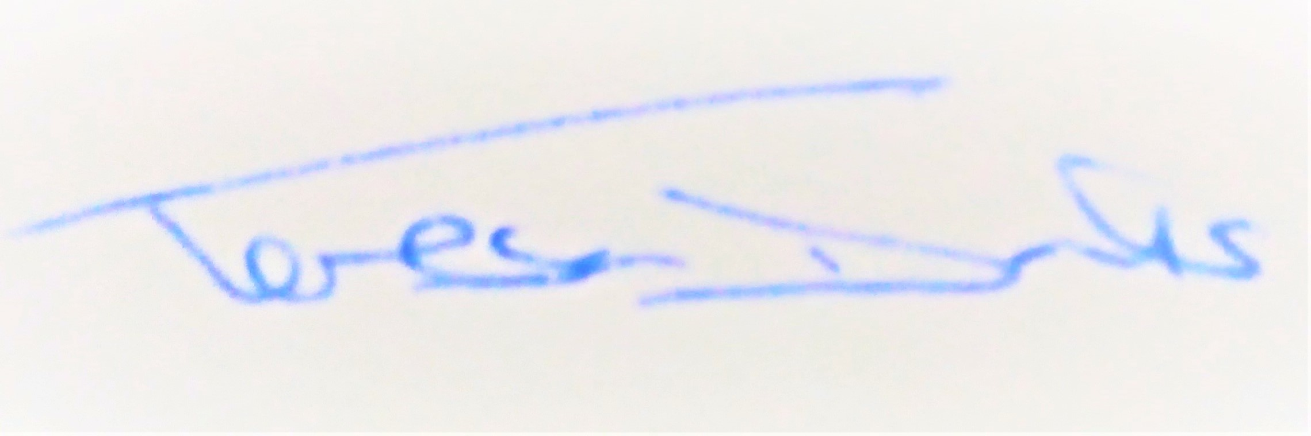
AGENDA
2023/01 | MEETING ADMINISTRATION
a.  b.  c. | Chairman’s welcome & to establish any intentions of recording the meeting  Apologies for Absence  Declarations of Interest on agenda items
2023/02  a. | To Approve the Draft Minutes of the Parish Council Meeting of 15th November 2022 and for the Chair to sign as a true record  Matters arising from the minutes of 15th Nov 2022
2023/03  a.  b.  c. | PUBLIC PARTICIPATION - For members of the public, County Councillors & District Councillors to speak  Public invited to speak  To receive Suffolk County Council report from Cty Cllr K Oakes  To receive District Council report from Dst Cllr D Pratt
2023/04  a.  b.  c. | Chair and Councillor Reports / Updates (on the night)  Chairman report  Councillor report(s) not requiring a decision  Clerk report
2023/05  a.  b. | SID Report & ANPR Initiative update (Cllr Cook)  SID report & update  ANPR update
2023/06  a. | BMSDC PLANNING CONSULTATION REQUESTS & PLANNING INSPECTORATE CONSULTATION REQUEST RECEIVED  Consultation of revisions to the Babergh & Mid Suffolk Planning Local Validation List (LVL)
2023/07  a. | GOVERNANCE & PROTOCOLS  To discuss & approve planning consultation delegation and procedure.  Suggested by Chairman:-  Where no EGM is called the Clerk is to:  1. repeat appropriate comments previously made in relation to applications for the same property.  2. repeat comments previously made in relation to the same development activity at the property.  3. respond "no comment” in all other circumstances
2023/08  a.  b.  c.  d.  e.  f.  g.  h.  i.  j.  k.  l.  m.  n. | FINANCIAL MATTERS  To Advise Previous Payments Made after meeting of 15th November 2022  - ICO Direct Debit - £35.00  - Village Hall Hire - £140.00  - Replacement De-Fib Pads - £115.20  - BMSDC Quiet Lanes - £50  - Clerk Wages December - £330.98  - Bank Service Charge - £18.00  To Advise of Income received up to 31st December 2022  - Bank Interest - £28.38  To discuss and authorise payments of invoices payable in January 2023  - Clerk Office Allowance, Expenses & Mileage - £31.70  - Clerk Wages January - £330.98  - Top Garden Services for October (late invoice) - £360.00  Balance of Accounts as of 31st December 2022:-  Current Account - £11,451.44  Savings Account - £ 11,274.73  Savings Account - £ _2,370.81  To consider and approve 3rd Quarter Accounts  To formally approve an increase in the Training budget for 2022-2023  To approve Election Refresher Training Request from the Clerk  To discuss and agree Recreation Ground (Asset) Action Plan from the working group formed in November and resulting Playground Maintenance quotes  To review & decide on the Cricket Club Grant Application of £1500  To review & decide on the Barcliff Grant Application of £150  To review & decide on the Battisford Village Hall Grant Application of £150  To review & agree a financial budget for 2023-2024  To review & agree a Precept for 2023-2024 and for the Chair and RFO to sign the form for BMSDC
2023/09  a.  b.  c.  d. | Ongoing Parish Projects and Resident Communications  Resident Query – Are the Priority Signs for Church Rd & Valley Rd going to be changed  To discuss Councillors findings on the Skatepark  To discuss a Tree Review  To discuss a Litter Pick
2023/10 | Items for the next agenda, next meeting on 21st March 2023 at 7pm

Link for Planning https://planning.baberghmidsuffolk.gov.uk/online-applications/ Note: LVL email sent on 12th Dec to all councillors

