BATTISFORD PARISH COUNCIL
Clerk: Teresa Davis 07719208444
clerk@battisfordpc.org.uk
http://www.battisfordpc.org.uk

The PRESS and PUBLIC are invited to attend, the Councillors are SUMMONED TO ATTEND THE BATTISFORD PARISH COUNCIL MEETING to be held at Battisford Village Hall on 21st March 2023 commencing at 7.00pm
Signed: 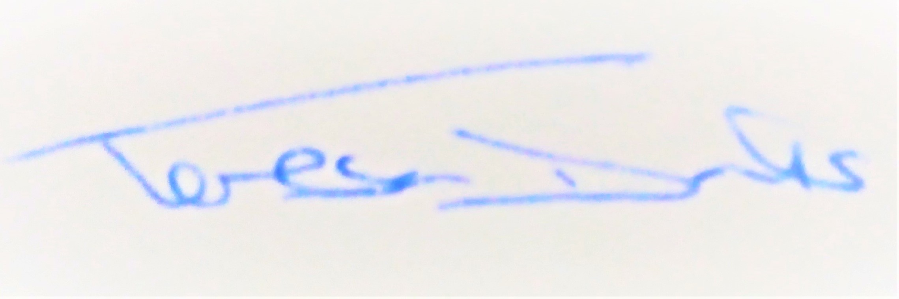
AGENDA
2023/15 | MEETING ADMINISTRATION
a.  b.  c. | Chairman’s welcome & to establish any intentions of recording the meeting  Apologies for Absence  Declarations of Interest on agenda items
2023/16  a.  b. | To Approve the Draft Minutes of the Parish Council Meeting of 17th January 2023 and the Draft Minutes of the EGM held on 21st February 2023 and for the Chair to sign as a true record  Matters arising from the minutes of 17th Jan 2023  Matters arising from the minutes of 21st Feb 2023
2023/17  a.  b.  c. | PUBLIC PARTICIPATION - For members of the public, County Councillors & District Councillors to speak  Public invited to speak  To receive Suffolk County Council report from Cty Cllr K Oakes  To receive District Council report from Dst Cllr D Pratt
2023/18  a.  b.  c. | Chair and Councillor Reports / Updates (on the night)  Chairman report  Councillor report(s) not requiring a decision  Clerk report
2023/19  a.  b. | SID Report & ANPR Initiative update (Cllr Cook)  SID report & update  ANPR update
2023/20  a.  b.  c. | BMSDC PLANNING CONSULTATION REQUESTS & PLANNING INSPECTORATE CONSULTATION REQUEST RECEIVED  DC/23/01103 – Two Storey Rear extension, Woodlands Farm, Bildesdon Rd  DC/23/01104 – Listed Building Consent, Woodlands Farm, Bildeson Rd  DC/23/00971 – Two Bay Cartlodge & log store, Gibbons Farm, Hascot Hill
2023/21  a. | CEMETERY  To discuss and agree a date for the annual Cemetery maintenance review including topple test and tidy.
2023/22  a.  b.  c.  d.  e.  f.  g.  h. | GOVERNANCE & PROTOCOLS  To formally approve planning consultation process, delegation and procedure.  To formally approve:-  The Data Protection, Retention, Management & Disposal Policy  Public Privacy Notice  Staff & Volunteer Privacy Notice  Email Privacy Notice Footer  To formally discuss and approve the wording for the Playground Entrance Signs  To discuss opting for the new Neighbourhood Priorities Statement rather than a Neighbourhood Plan or Parish Plan  To discuss and agree either on ‘battisfordparishcouncil.gov.uk’ or ‘battisford-pc.gov.uk’?
2023/23  a.  b.  c.  d.  e.  f.  g.  h. | FINANCIAL MATTERS  To Advise Payments Made after meeting of 17th January 2023  - Clerk Wages February - £330.98  - Barcliff Grant - £150  - Battisford Village Hall Grant - £150  - Battisford Cricket Club Grant - £1500.00  - BMSDC Annual Play Inspection - £77.47  - (Locality Award Expenditure on Bench) - £990.80  - Swan’s Nursery (5 Trees) - £113.57  - Sandy Lane Nursery (2 Trees) - £54.00  - The Green Rental - £325.00  To advise of Income received up to 28th February 2023  - BMSDC Locality Award - £1323.15  - SALC Duplicate Payment refund - £48.00  - Cemetery - £25.00  - SCC Locality Award from 2021 - £822.86  To discuss and authorise payments of invoices payable in March 2023  - Clerk Office Allowance, Expenses & Mileage - £103.55  - Clerk Wages March - £330.98  - SALC payroll service - £54.00  Balance of Accounts as of 28th February 2023:-  Current Account - £_9,830.61  Savings Account - £ 11,299.73  Savings Account - £ _2,370.81  To discuss and agree playground inspection training eg: ROSPA costs, numbers, availability  To discuss and agree playground flooring following quotes received so far from Online Playgrounds & HAGS  To Discuss and Decide on the Cycling Belles Grant application of £44  To Discuss and Agree, including a budget, Coronation Plans for May
2023/24  a.  b.  c. | Ongoing Parish Projects and Resident Communications  Resident Query – Dog Bin for Church Road  To discuss and agree a Playground Working Group maintenance day  Resident Query – Larger Goal Post
2023/25 | Items for the next agenda, the Annual meeting on 16th May 2023 at 7pm

Link for Planning https://planning.baberghmidsuffolk.gov.uk/online-applications/

