BATTISFORD PARISH COUNCIL
Clerk: Teresa Davis 07719208444
clerk@battisfordpc.org.uk
http://www.battisfordpc.org.uk

The PRESS and PUBLIC are invited to attend, the Councillors are SUMMONED TO ATTEND THE BATTISFORD PARISH COUNCIL MEETING to be held at Battisford Village Hall on 21st Sept 2023 commencing at 7.00pm
Signed: 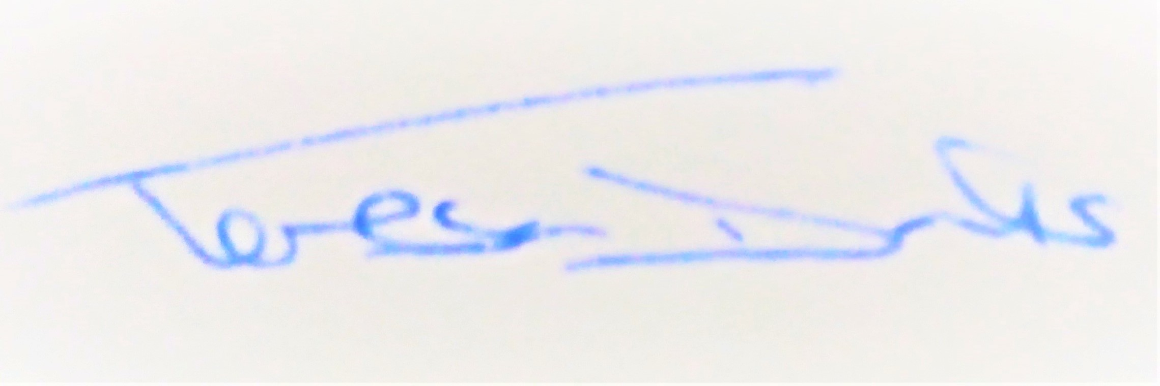
AGENDA
2023/75 | MEETING ADMINISTRATION
a.  b.  c. | Chairman’s welcome & establish any intentions to record the meeting  Apologies for Absence – Cllr A Card  Declarations of Interest on agenda items
2023/76  a. | To Approve the Draft Minutes of the Parish Council Meeting of 19th Sept 2023 and for the Chair to sign as a true record  Matters arising from the minutes of 19th Sept 2023 not on the agenda or in the  Clerk report
2023/77  a.  b.  c. | PUBLIC PARTICIPATION - For members of the public, County Councillors & District Councillors to speak  Public invited to speak  To receive Suffolk County Council report from Cty Cllr K Oakes  To receive District Council report from Dst Cllr D Pratt
2023/78  a.  b.  i.  ii.  c. | Chair and Councillor Reports / Updates (on the night)  Chairman report  Councillor report(s) not requiring a decision  Cllr Greenwood on Cemetery Gates  Cllr Wilson on Taxi Bus  Clerk report
2023/79  a.  b. | SID Report, ANPR Initiative update & Speed Safety (Cllr Cook)  SID report & update  ANPR update
2023/80  a.  b.  c.  d.  e.  f.  g. | BMSDC/SCC/National - CONSULTATIONS RECEIVED  Planning DC/23/05144 – 2 School House, Battisford  Planning DC/23/05076 – Bungeons Farm, Battisford  Planning DC/23/05083 – Bungeons Farm, Battisford  Mid Suffolk Consultation ‘Have your say’ on Corporate Priorities  Mid Suffolk Corporate Governance Review – Battisford Boundaries  Mid Suffolk Planning Consultation – Local Listed Building Consent Order  National Government Climate & Ecology Bill
2023/81  a.  b.  c.  d.  e. | GOVERNANCE and PROTOCOLS  To discuss updates received from Cllr Cook and Cllr Cleaver on PPP (People Place Plan)  To review Playground Inspections and Working Party following Volunteer Plays Equipment Inspection Qualification  To discuss the regular frequency of Parish Council meetings (not EGMS)  To discuss the cost of living for Battisford Parish (Citizens Advice Bureau invited)  To discuss and agree SALC opportunities for Training and Conferences
2023/82  a.  b.  c.  d.  e.  f.  g.  h.  i.  j.  k. | FINANCIAL MATTERS  Balance of Accounts as of 31st October 2023:-  Current Account - £9,562.60  Savings Account - £12,804.06  To Advise of payments made since 19th Sept 2023 meeting  - Clerk Wages October - £330.98  - Top Garden Payment Sept - £295.20  - Top Garden Payment Oct - £295.20  - ICO Direct Debit - £35.00  - SALC Payroll - £90.00  - Play Safety - £474.00  - Quarterly Bank Fee £18.00  To Advise of Income Received since 19th Sept 2023 meeting  - Bank Interest - £83.80  - Final Precept Payment - £6,946.50  To discuss and authorise payments of invoices payable in Nov 2023  - Clerk Office Allowance, Expenses & Mileage – £56.90  - Clerk Wages November - £330.98  - Playground Supervisor reimbursement for maintenance - £32.60  To consider the grant application made by the Village Hall for £1,500  To consider the donation request email from the Parish Magazine  To consider the donation request email from Citizens Advice Bureau  To acknowledge receipt of the backdated NALC pay rise for employees of the Council  To receive and discuss the Annual Asset Report from the Clerk  To receive and accept the 2Qtr accounts report  To receive and agree the 4yr Budget
2023/83  a.  b. | Volunteer & Resident Communications  Defibrillator Volunteer email  Village Hall Fete Request
2023/84  a. | This item will be closed to the public and press on the grounds of sensitive personal information – the Chair will ask those in the public area to leave  To discuss the Employment Panel Recommendations
2023/85 | Items for the next agenda, next meeting currently on 16th January 2023

Link for Planning https://planning.baberghmidsuffolk.gov.uk/online-applications/ Note: emails sent on 10th Nov to all councillors

